**Project Proposal**

Our github: <https://github.com/eerofeeva/Pints-and-Transit.git>

**About:**

This site will provide interesting data about the bar and restaurant scene in the twin cities from Eater and also historical data of nice ride (short term rental) bike trips and the locations of businesses that have liquor licenses. There will also be some light analysis on any connection between bars/restaurants and where bike trips on nice ride start and stop.

**Sources:**

Nice ride csv files (2020 data): <https://s3.amazonaws.com/niceride-data/index.html>



Off sale liquor license: <https://opendata.minneapolismn.gov/datasets/off-sale-liquor>

On sale Liquor license: <https://opendata.minneapolismn.gov/datasets/on-sale-liquor>

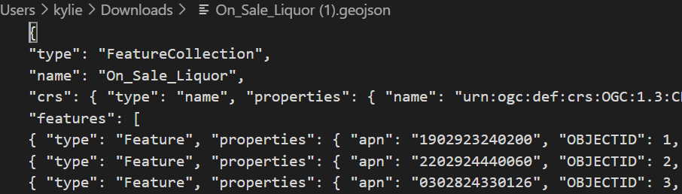

D3 connections to off sale, on sale data(Elena)

Upload nice ride data (Kelly)

**Structure:**

1. Website (3 pages): Simple design with a navbar to get to other pages
2. 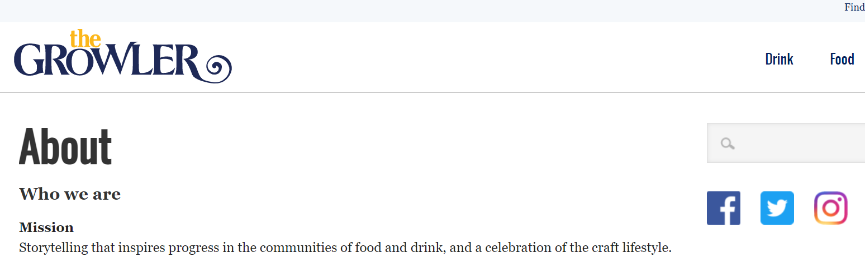
   1. Landing page/Index.html (Kory will build structure)
      1. Web scrap: Scrap the Eater (<https://twincities.eater.com/>) for restaurant/brewery/bar articles and pictures for the Twin Cities (Kylie)

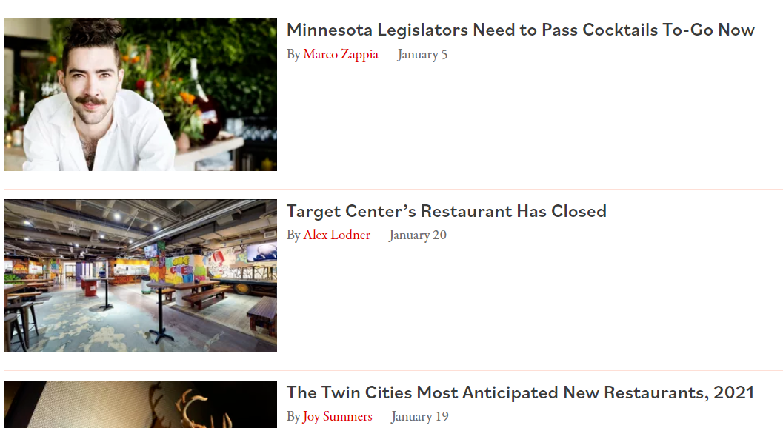

* + 1. About section
  1. Map page
     1. Filter and metadata of bike (start and stop coordinates)/ beverage locations
        1. We’d like to do a heatmap but will start with markers

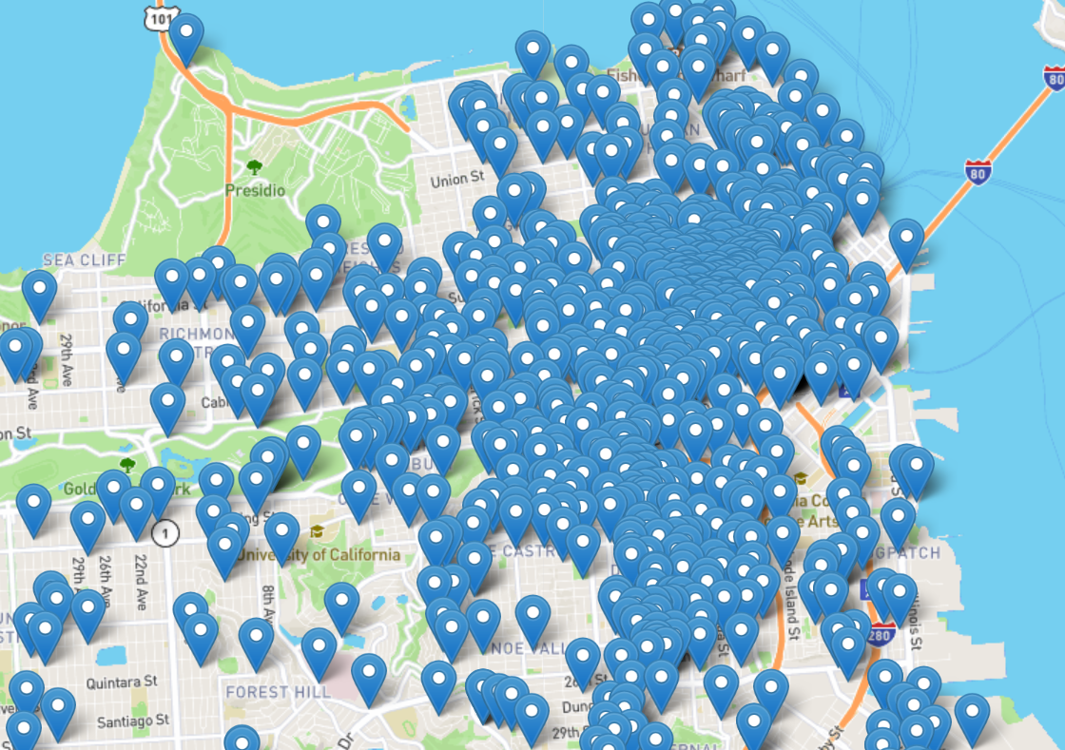

* + - 1. Potential filters for month of bike activity or stop/start points
    1. If we have time – neighborhood boundaries in Minneapolis
  1. Graphs with minimal analysis (Kelly)
     1. Not decided yet, but planning a few graphs for types and number of liquor licenses
     2. Some written analysis

1. We haven’t decided on which JS library to use yet, but at the moment we’re looking at Izimodal: <https://izimodal.marcelodolza.com/#modal-default>
   1. Potential uses:
      1. Have an alert popup when user does an action (easiest)
      2. 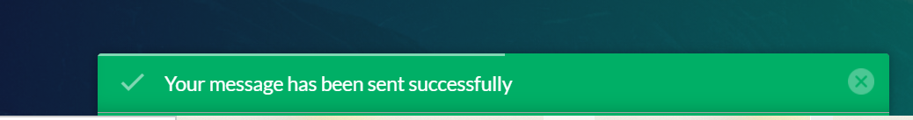
      3. Modal window pop up that could do ajax calls or calls to different sites (if we have time)
      4. Display a video (if we have time)

